1.Identification of the substance
1.1 Trade Name: BETTOMENT
1.2 The purpose of the material: Concrete concribution material
1.3 Manufacturer / Supplier:
BETTON Yapı Kimyasalları San. ve Tic. Ltd. Şti.
DES Sanayi sitesi 112. Sokak D2 Blok No: 2 Ümraniye / İSTANBUL
TEL : 00- 90- 216- 314- 12 11
FAX: 00- 90- 216- 364- 62 54
Emergency information:Quality Assurance Deparment : +90.216.314.39.36
2. Hazard İdentification
2.1 The classification of substances and mixtures:
Acute toxicity (dermal, inhalation,oral), Category 3, H301+H311+H331: Toxic is swollowed,
in contact with skin or if inhaled
Skin corrosion / irritation, Category 1B,H314: Causes severe skin burns and eye damage.
Skin sensitisation, Category 1,H317: May cause an allergic skin reaction
Germ cell mutagenicity, Category 2,H341: Suspected of causing genetic defects.
Carcinogenicity, Category 1B, H350: May cause cancer.

2.2 Label elements:
GHS05 GHS06 GHS08
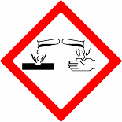
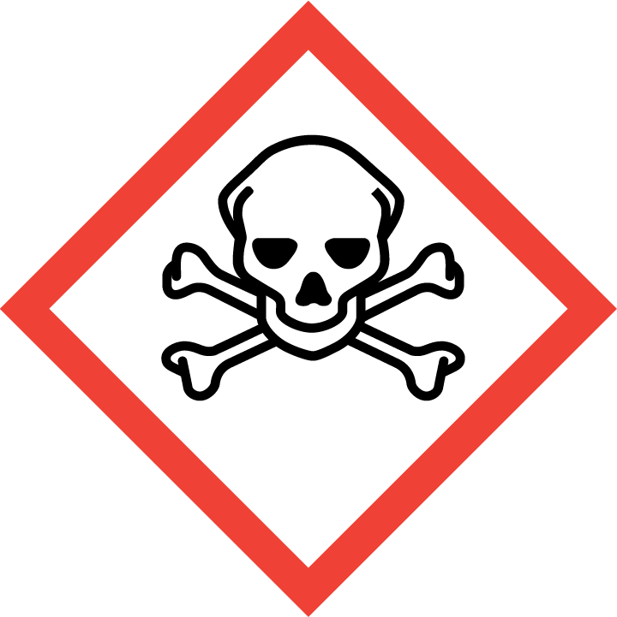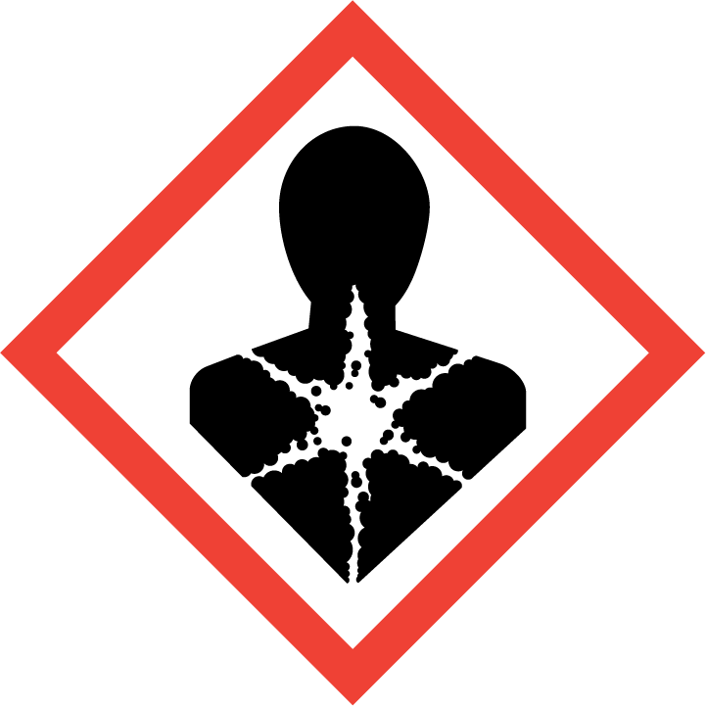

H301+H311+H331: Toxic is swollowed, in contact with skin or if inhaled
H314: Causes severe skin burns and eye damage.
H317: May cause an allergic skin reaction.
H341: Suspected of causing genetic defects.
H350: May cause cancer.
2.3 Other Hazard: None

3. Composition / Data on Components
3.1 Mixtures: Water reducer; melamine sulfonate aqueous solution
3.2 Materials:
Mixture | EC number | Cas  number | Concentration | SEA
 |  |  |  | Class H expressions
Formaldehyde | - | 50-00-0 | < % 0,2 | Acute toxicity,Category 3: H311  Acute toxicity(inhalation), Category 3, H331  Acute toxicity(oral), Category 3, H301  Skin corrosion/irritation, Category 1B, H314  Skin sensitisation, Category 1, H317  Germ cell mutagenicity,Cateogory2,H341  Carcinogenicity, Category 1B, H350

4.First aid Measures
4.1General information: In terms of material usage, althoughnot harmfull to human health;
Observe the general first aid.

4.2 Inhalation: Remove the affected person to fresh air
Keep the patient warm and you rest
If breathing is irregula, give artificial respiration
Do not give anything by mouth
If symptoms persist, colsult a doctor
4.3 Skin Contact: Wash the affected area with soap and plenty of water. Consult a doctor if
İrritation persist
4.4 Eye Contact: Wash immediately with plenty of water
4.5 İngestion: Drink plenty of water if the person is conscious.Do not induce vomiting and
Seek medical advice.
Doctoral notes:
Symptoms: According to the best of our knowladge; experience regarding the effects of
Acute and chronic systemic health are not available.
Treatment: There is no known antidate

5.Fire Fighthing Measures
5.1 Suitable extinguishing agents: Water jet; Carbon dioxide, Foam, Dry powder
5.2 Fire extinguishers should not be used
5.3 Combustion special damages in the form of exposure to emerging gas: After drying
Carbon dioxide anf sulfur oxides and ammonia will occur.
5.4 Protective Equipment: Use breathing apparatus in case of fire

6.Accidental Release Measures
6.1 Personal Precations: Protective glasses, plastic or rubber gloves, protective overalls
6.2 Environmental Precations: The water channels, do not let the soil and the sanitory
Sewer system
6.3 Method for cleaning up: Collect the product. Transfer into suitable containers for
Recycling and sluices to.
Additional İnformation:

7. Handling and Storage
7.1 Handling:
7.1.1 Safe Handling İnformation: No special measures required
7.1.2 Protection againts fire and explosion: No special measures required
According to the legislation on flammable liquids class: None
7.2 Storage:
7.2.1 Measures to be taken during storage: There is no need for special conditions
7.2.2 Measures to be taken in public landfills: There is no need
7.2.3 More information about storage: Storage in a dry place prevents or at least
reduces the accumulation dust.
According to the legislation on flammable liquids class: None

8.Exposure controls / Personal protection
8.1 Exposure limit values:
8.2 Exposure controls

8.2.1 Occontrolscupational exposure
General protection and hygiene measures:
Due to general precations for the use of substances should be thick.
Wash hands in breaks and after work
Use protection cream for skin protection
8.2.1.1 Respiratory protection: You do not need a special prevention
8.2.1.2 Protection of hands: Rubber gloves are
8.2.1.3 Eye protection: Goggles
8.2.1.4 Skin protection: Normal business attire
Environmental exposure controls: The water channels, do not let the soil and the sanitory
sewer system.

9.Phsical and Chemical Properties
9.1 General İnformation:
9.1 1 The physical state of matter: Liquids
9.1.2 Odor
9.1.3 Color: Transparent colorless
Value Method
Change in status
Melting Point / Melting Range Not applicable
Boiling Point / Boiling Range 95- 105 ⁰ C
Flaspoint Not applicable
Self- Flammability Product itself is not combustible

Risk of explosion Product is not explosive
Thermal decamposition > 720 ⁰ C
Dansity at 20 ⁰ C About 1,162- 1,222 g / cm³
Solubility in water / water- miscible Water – miscible products
PH at 20 ⁰ C 9,0 – 12,0

10.Stability and Reactivity
Dangerous decomposition products: No
Dangerous reactions: No

11. Toxicological Data
General Toxicity information:
Acute oral toxicity ( LD50, mouse): 5000 mg/kg higher ( on a solids basis)
Skin irritating: Not irirtating
Mutagenic: Not mutagenic in the AMES test
Other İnformation: May cause sensitization in susceptible people.

12. Ecological İnformation
BOD: 33 mg / g
COD: 360 mg / g
Fish Poisoning:
LC50 : > 560 mg/ l ; 48 hour ( Lecissus idus )

Poisoning for bacteria:
EC10: 1800 mg / l ( Pseudomonas putia )
Other information: The water channels, do not let the soil and the sanitory sewer system

13. Disposal İnformation
Adherence to local lagislation acceptable to the sewage treatment plant.

14. Transport İnformation
Regulations on the Transport of Dangerous Goods by Road ( RG24.10.2013- number 28801)
has been taken in to account.
ADR / RID / IMDG / IATA
For this product ADR, RID, IMDG VE ICAO ( IATA ) transport rules do not apply.
14.1 UN No: Not applicable
14.2 Proper shipping name: Not applicable
14.3 Class: Not applicable
14.4 Packaking group: Not applicable
14.5 Environmental hazards: Not applicable
14.6 Special precations for user: Not applicable
14.7 Annex II of MARPOL 73/78 and the IBC code by public transport: Not applicable
Other İnformation: This products is not classified as dangerous goods in any transport
legislation.

15. Regulatory İnformation

Labelling: According to EC directive on the labeling of preparations; Danger symbol is
not required.
The code letter and hazard markers product: There is no danger icon.
Danger of determining components of labeling :

16. Other İnformation
This data is based on our presenre knowledge. However, they shall not constitute a
guarentee for any specific product features and hall not legally valid contractual relationship.
Precautionary statements:
P102: Keep out of reach of chidren.
P302+P352: IF ON SKIN: Wash with plenty of water
P501: Dispose of contents / container to…..

GBF Authorized Person: safiye@betton.com.tr
Document Date: 03.09.2015
Document Number: GBF - 2258

